Reproduction, Development, and Genetics Review

Vocabulary:
- Heredity: the study of how genes are passed from generation to generation (family trees)
- DNA: genetic material, template of life, arranged in subunits (ATCG)
- RNA: chemical messages that help transfer of genetic material, arranged as subunits (AUCG) and coded as codons (subunit triplets)
- Genes: a group of DNA that controls a specific trait
- Chromosome: a group of genes found in the nucleus (arrangement for reproduction)
- Mutation: a change in the DNA or RNA that results in different amino acids being made, with different proteins being made, and therefore, different traits being expressed
- Trait: the observable expression of proteins, the characteristics of an organism
- Mitosis: cell division, providing an exact copy of a parent cell. This process is found in humans when cells are repairing damage (injuries) or following fertilization in a zygote

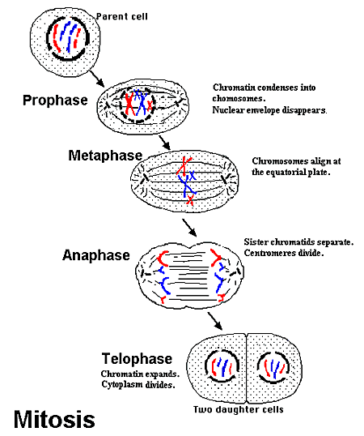

- Meiosis: the formation of gametes (sperm and egg), 4 cells being produced with half the genes of the parent cell. Happens in the testis of males and the ovary of females.
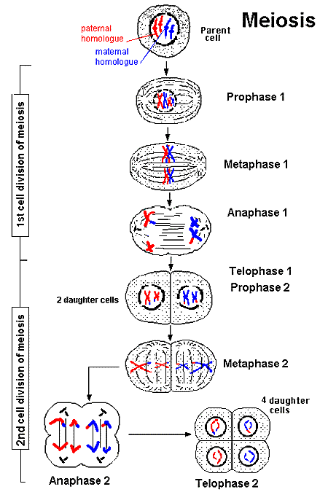
  - Crossing over or recombination: during meiosis genes might changes places so that it increases genetic diversity
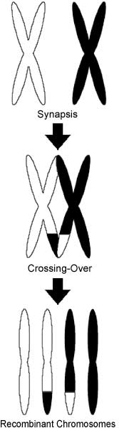
- Asexual reproduction: exact copy of 1 parent (genetically identical)
  - Cloning: done in a lab, genes from a single parent are transferred to offspring
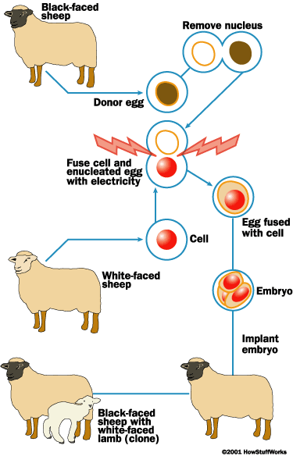
  - Vegetative propagation: taking a shoot from a plant and placing it in soil to have an exact copy of the parent
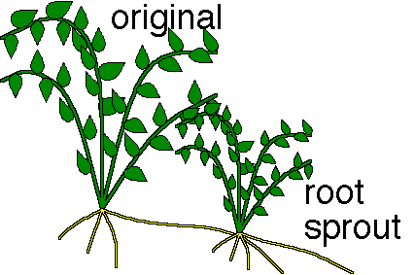
  - Budding: a piece of the parent grows to a bud then separates from the parent organism
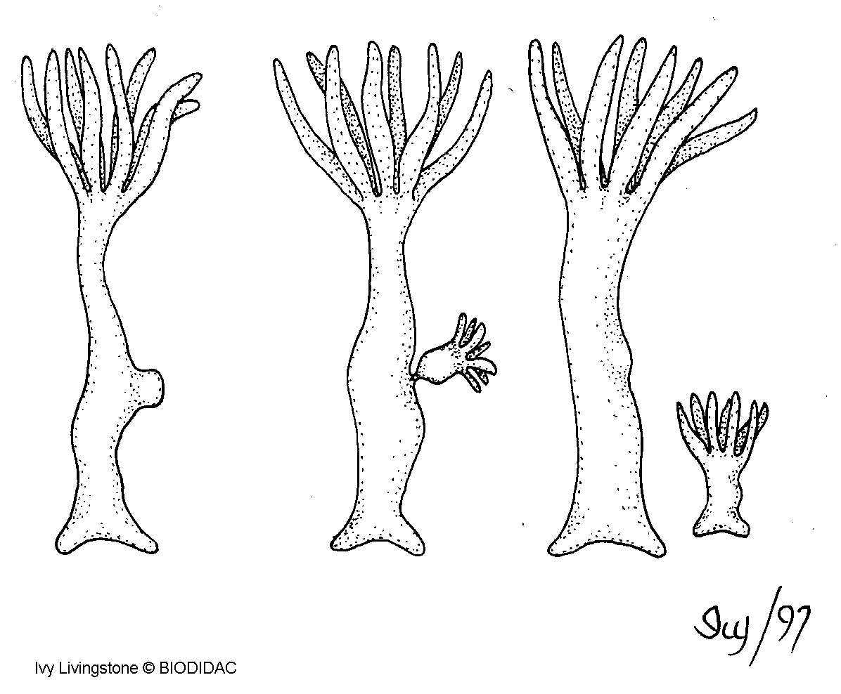
- Sexual Reproduction: the combination of genetic material from 2 parents to give rise to offspring that have characteristics of both parents
  - Gametes: the sex cells of organisms (sperm and egg)
  - Genetic recombination: the process of genes being sorted when the egg and sperm unite to form a zygote
  - Fertilization: when sperm and egg fuse to form the zygote
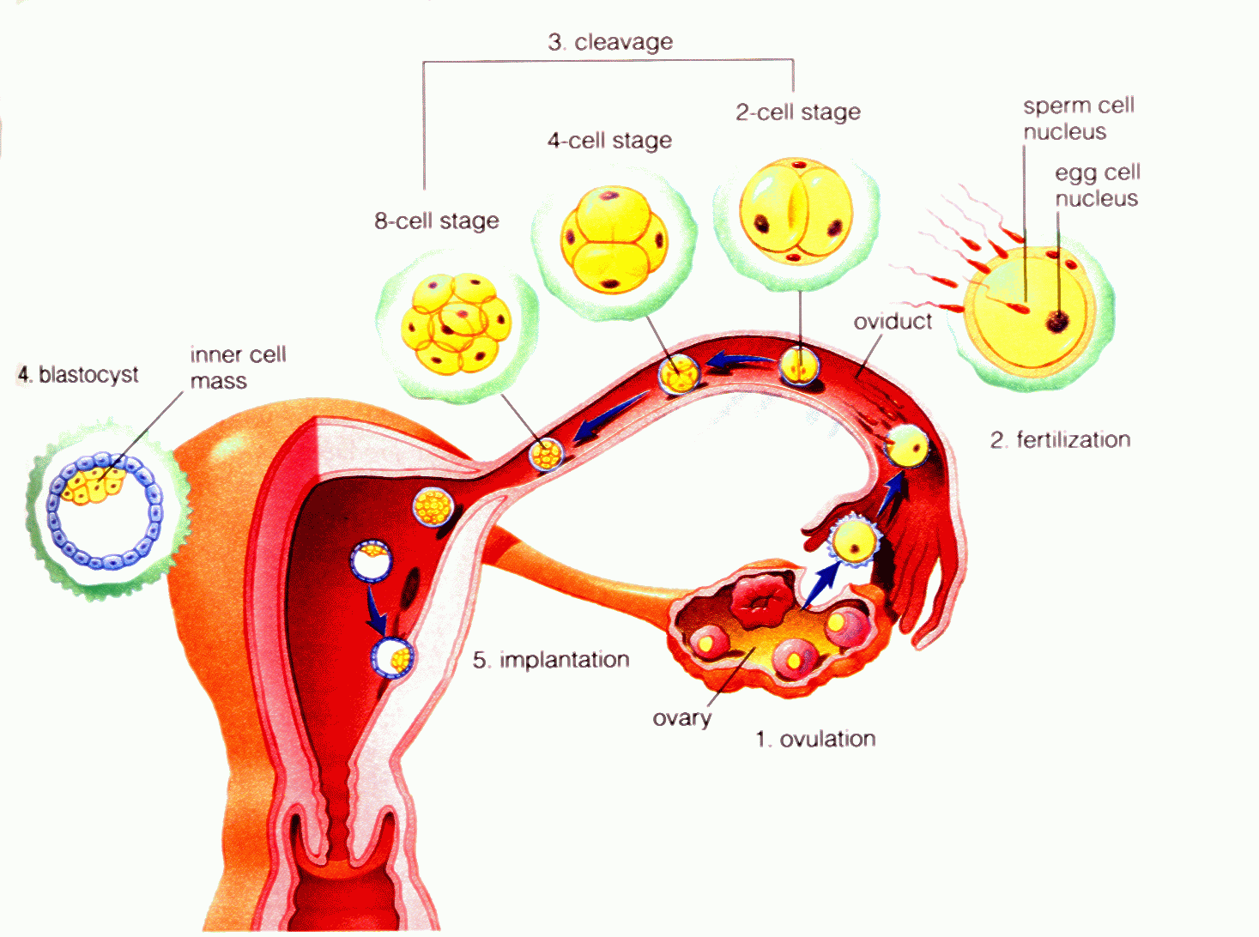
  - Zygote: fertilized egg until the time of differentiation
  - Differentiation: when cells become specialized for jobs in multicellular organisms (a cell becomes a heart cell or a liver cell or a brain cell etc)
  - Development: when the zygote becomes an embryo following differentiation process and organs start to form
- Reproduction specific to mammals (humans):
  - Ovary: produces egg cells in females
  - Testis: produces sperm cells in males
  - Fallopian tubes (oviduct): connects ovary to the uterus, site of fertilization
  - Uterus: location for developing baby
  - Zygote: stage where egg has been fertilized and it undergoes mitosis until differentiation
  - Embryo: stage during development of offspring
  - Fetus: stage after development, where the baby grows
  - Estrogen and progesterone: female hormones that help with developing and mature egg, thickening of the uterus lining and preparing the female before and during pregnancy
  - Testosterone: male hormone that is responsible for the production of sperm and secondary sex characteristics (voice getting deeper, hair growth)
  - Placenta: the organ that is responsible for exchange of materials between the mother and the developing baby (remember, blood of the mother and the fetus never mix!)
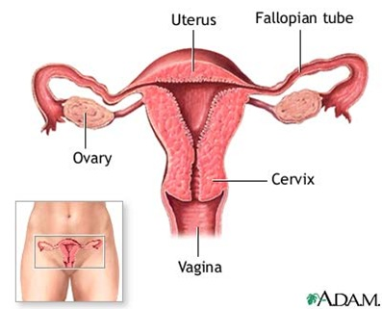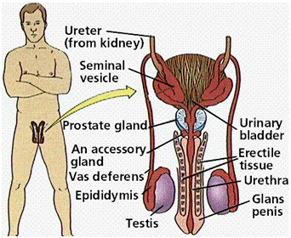

- Biotechnology: the use of laboratory procedures to study and change genetics.
  - Bacterial Transformation or Recombinant DNA: taking the gene that produces a desired protein and placing it in a bacteria so that we can get a large amount of the protein (like insulin) quickly
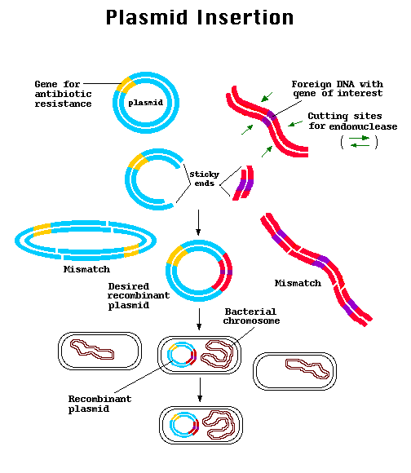
  - Gel Electrophoresis: cutting up DNA and running it on a gel to determine relationships between organisms (paternity tests, evolutionary relationships)
Protein Synthesis: assembly of amino acids into proteins at the ribosome
Transcription: process of turning the DNA template into mRNA so that the instructions for making a protein can travel to the ribosome (A=U, C=G during transcription)
Translation: the process of taking the mRNA and changing it into amino acids so that proteins can be synthesized (use the codon chart in order to do this process)
Codon: a set of 3 bases together that will code for a single amino acid

Test Hints:
- Focus on how the genes are passed from parent to offspring
- When dealing with diseases, only diseases that affect the genes or mutations in the gametes will be passed from parent to offspring!
- During pregnancy, the actions of the mother can affect the baby, even though their blood never mixes. Drinking, drug use, and smoking can lead to birth defects, fetal alcohol syndrome, or asthma
- Mutations in the gametes will lead to a species evolving if those mutations lead to beneficial adaptations.
- Genetic variation from sexual reproduction is GOOD for increasing biodiversity and ensuring that a species survives (the more diverse a species, the greater their chances of survival if there is a major change to the environment)
**Use other parts of the test. Often the questions are repeated throughout the test or answers can be found later on (or earlier on in the test) to help you out!

Practice Regents Questions:

The instructions for the traits of an organism are coded in the arrangement of
(1) glucose units in carbohydrate molecules
(2) bases in DNA in the nucleus
(3) fat molecules in the cell membrane
(4) energy-rich bonds in starch molecules

Which statement is true regarding an alteration or change in DNA?
(1) It is always known as a mutation.
(2) It is always advantageous to an individual.
(3) It is always passed on to offspring.
(4) It is always detected by the process of chromatography.

Which statement best describes human insulin that is produced by genetically engineered bacteria?
(1) This insulin will not function normally in humans because it is produced by bacteria.
(2) This insulin is produced as a result of human insulin being inserted into bacteria cells.
(3) This insulin is produced as a result of exposing bacteria cells to radiation, which produces a mutation.
(4) This insulin may have fewer side effects than the insulin previously extracted from the pancreas of other animals.
In animals, the normal development of an embryo is dependent on
(1) fertilization of a mature egg by many sperm cells
(2) production of new cells having twice the number of chromosomes as the zygote
(3) production of body cells having half the number of chromosomes as the zygote
(4) mitosis and the differentiation of cells after fertilization has occurred

Which process normally occurs at the placenta?
(1) Oxygen diffuses from fetal blood to maternal blood.
(2) Materials are exchanged between fetal and maternal blood.
(3) Maternal blood is converted into fetal blood.
(4) Digestive enzymes pass from maternal blood to fetal blood.

Individual cells can be isolated from a mature plant and grown with special mixtures of growth hormones to produce a number of genetically identical plants. This process is known as
(1) cloning
(2) meiotic division
(3) recombinant DNA technology
(4) selective breeding

The diagrams below represent organs of two individuals. The diagrams are followed by a list of sentences. For each phrase in questions 47 through 49, select the sentence from the list below that best applies to that phrase. Then record its number in the space provided.
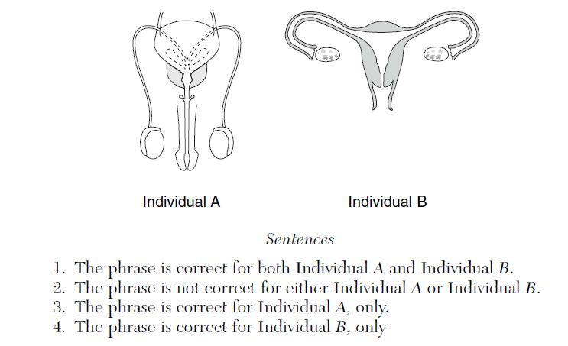
Contains organs that produce gametes [1] ______________________

Contains organs involved in internal fertilization [1]_______________________

Contains a structure in which a zygote divides by mitosis [1]_________________
The diagram below represents reproduction of single-celled organism A, which has a
normal chromosome number of 8.
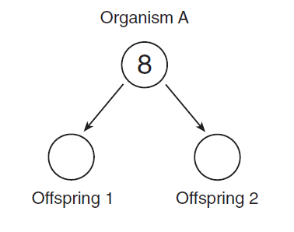
In the circles representing offspring 1 and offspring 2, write the number of chromosomes that result from the normal asexual reproduction of organism A. [1]

Base your answers to questions 69 through 71 on the quotation below and on your
knowledge of biology.

“Today I planted something new in my vegetable garden — something very new, as a matter of fact. It’s a potato called the New Leaf Superior, which has been genetically engineered — by Monsanto, the chemical giant recently turned “life sciences” giant — to produce its own insecticide. This it can do in every cell of every leaf, stem, flower, root, and (here’s the creepy part) spud [the potato].”

Source: New York Times Sunday Magazine,
Michael Pollan, 10/25/98

State two reasons that a gardener might choose to grow this new variety of plant. [2]
1. ____________________________________________________________________
_____________________________________________________________________
_____________________________________________________________________
2. ____________________________________________________________________
_____________________________________________________________________
_____________________________________________________________________
State one possible disadvantage of the synthesis of an insecticide by potatoes. [1]
_______________________________________________________________________
_______________________________________________________________________
_______________________________________________________________________
Explain why every cell in the New Leaf Superior potato plant is able to produce its own insecticide. [1]
_______________________________________________________________________
_______________________________________________________________________
_______________________________________________________________________

To produce large tomatoes that are resistant to cracking and splitting, some seed companies use the pollen from one variety of tomato plant to fertilize a different variety of tomato plant. This process is an example of

(1) selective breeding (3) direct harvesting
(2) DNA sequencing (4) cloning

Base your answers to questions 15 and 16 on the diagram below, which represents the human female reproductive system.
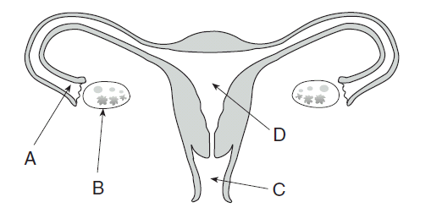
New inherited characteristics may appear in offspring as a result of new combinations of existing genes or may result from mutations in genes contained in cells produced by structure
(1) A (3) C
(2) B (4) D

In which part of this system does a fetus usually develop?
(1) A (3) C
(2) B (4) D

Which phrase best describes a process represented in the diagram below?
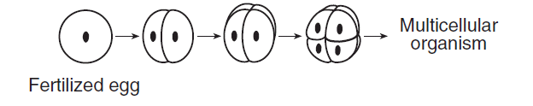

(1) a zygote dividing by mitosis (3) a gamete dividing by mitosis
(2) a zygote dividing by meiosis (4) a gamete dividing by meiosis

Human egg cells are most similar to human sperm cells in their
(1) degree of motility
(2) amount of stored food
(3) chromosome number
(4) shape and size

The diagram below represents the reproductive system of a mammal.

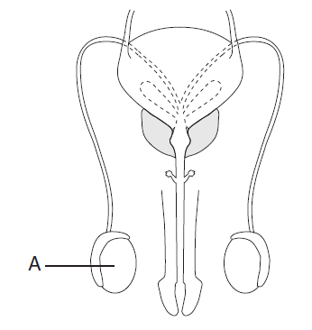
The hormone produced in structure A most directly brings about a change in
(1) blood sugar concentration
(2) physical characteristics
(3) the rate of digestion
(4) the ability to carry out respiration

The diagram below shows a process that can occur during meiosis.
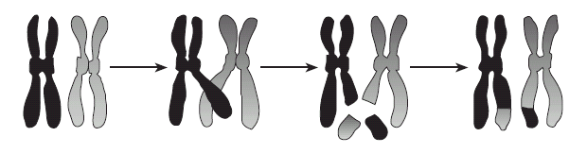
The most likely result of this process is
(1) a new combination of inheritable traits that can appear in the offspring
(2) an inability to pass either of these chromosomes on to offspring
(3) a loss of genetic information that will produce a genetic disorder in the offspring
(4) an increase in the chromosome number of the organism in which this process occurs

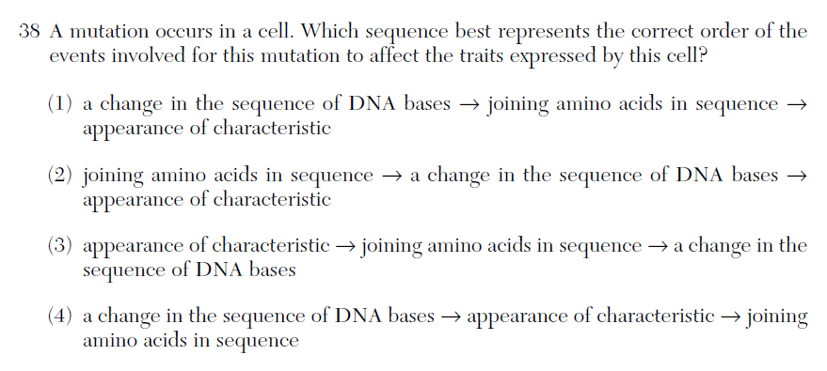
Recently, scientists noted that stained chromosomes from rapidly dividing cells, such as human cancer cells, contain numerous dark, dotlike structures. Chromosomes from older human cells that have stopped dividing have very few, if any, dotlike structures. The best generalization regarding these dotlike structures is that they
(1) will always be present in cells that are dividing
(2) may increase the rate of mitosis in human cells
(3) definitely affect the rate of division in all cells
(4) can cure all genetic disorders

Compare asexual reproduction to sexual reproduction. In your comparison, be sure to include:
• which type of reproduction results in offspring that are usually genetically identical to the previous generation and explain why this occurs [2]
• one other way these methods of reproduction differ [1]
_______________________________________________________________________
_______________________________________________________________________
_______________________________________________________________________
_______________________________________________________________________
_______________________________________________________________________
_______________________________________________________________________

A gene that codes for resistance to glyphosate, a biodegradable weedkiller, has been inserted into certain plants. As a result, these plants will be more likely to
(1) produce chemicals that kill weeds growing near them
(2) die when exposed to glyphosate
(3) convert glyphosate into fertilizer
(4) survive when glyphosate is applied to them

A biotechnology firm has produced tobacco plants that synthesize human antibodies that prevent bacterial diseases. One of the first steps in the production of these plants required
(1) using natural selection to increase the survival of antibody-producing tobacco plants
(2) inserting human DNA segments into the cells of tobacco plants
(3) using selective breeding to increase the number of antibody genes in tobacco plants
(4) growing tobacco plants in soil containing a specific fertilizer

Changes in the genetic code of a human can be transmitted to offspring if they occur in
(1) cancer cells (3) cell membranes
(2) gametes (4) antibodies

The development of specialized tissues and organs in a multicellular organism directly results from
(1) cloning (3) meiosis
(2) differentiation (4) evolution

